Introduction 1
1.1 Biophysics Lab Optical Tweezer System 1
1.2 Safety 1
1.3 Care of Equipment 1
1.3.1 Spatial Light Modulator 1
1.3.2 Microscope Objectives 1
1.3.3 Laser 1
2 System Components 2
2.1 Microscope 2
2.2 Lamp Control 2
2.3 Fluorescence Control 3
2.4 SLM 3
2.5 Laser and Power Supply 4
2.6 Motorized Stage, Joystick and Proscan II Controller 4
2.7 IR Viewing Scope and Card 5
3 Getting Started 5
3.1 Power on the Stage 5
3.2 Using the Microscope 5
3.3 Trapping 6
4 Advanced Operation 6
4.1 Computer Control of Stage 6
4.2 Arryx LabRyx 7
4.2.1 Recording Video 7
4.2.2 Selecting Microscope Objective 7
4.2.3 Manipulating Traps 7

Introduction

Biophysics Lab Optical Tweezer System
The system consists of an inverted microscope adapted for fluorescence microscopy and a 1064 nm laser for trapping. The microscope has a motorized stage which can be controlled with the joystick or computer. For control of the laser trap the optical train includes a Spatial Light Modulator (SLM) which can split the beam into up to 200 smaller traps. This kind of control is called Holographic Optical Trapping (HOT).

Safety
The laser is an 800 mW 1064 nm laser and can burn the skin or cause blindness if care is not taken. The beam is not visible so if there is any doubt about its location the operator must use either the IR viewing scope or the viewing card to see it. The laser has a shutter that can be opened and closed at the front aperture.

Care of Equipment

Spatial Light Modulator
Do not under any circumstance attempt to clean or touch the window on the SLM located on the right side of the table.

Microscope Objectives
Take care not to bang the objective lenses. Also make sure that you know what objective you are using before putting oil or water on it.

Laser
Switch the laser on when you start and off when you leave, in between use the shutter on the front aperture to block the beam.

System Components

Microscope
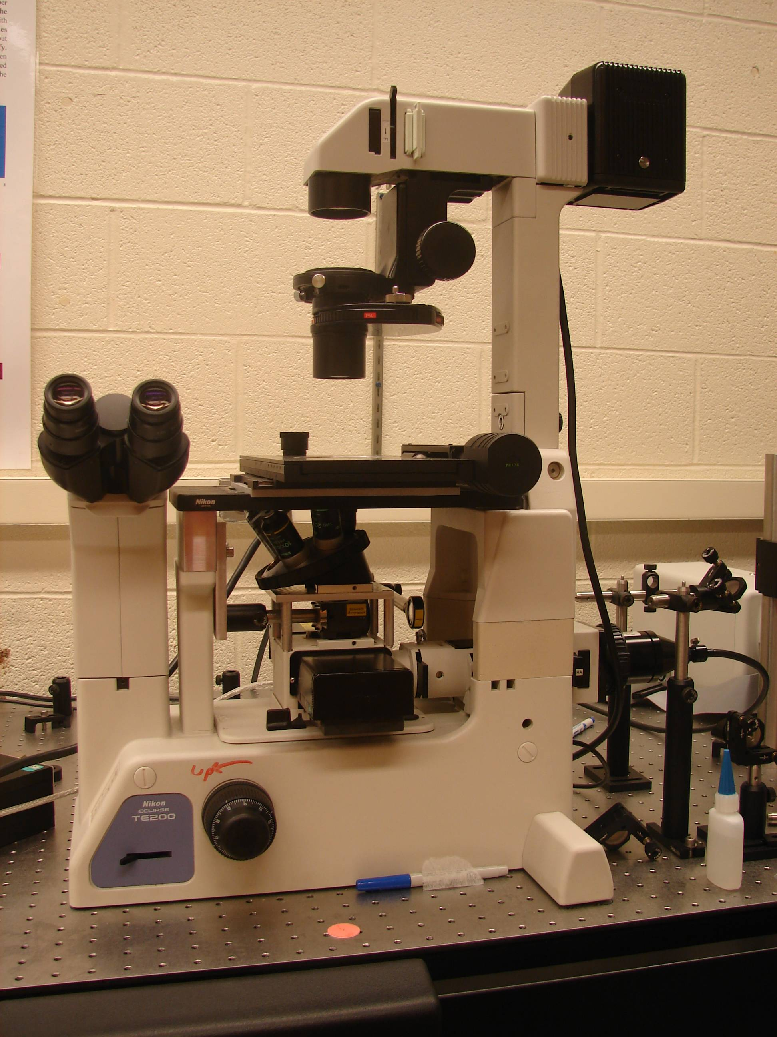
Filter Box
Microscope Objectives
Focus
View Selector
Stage

Lamp Control

Fluorescence Control

SLM
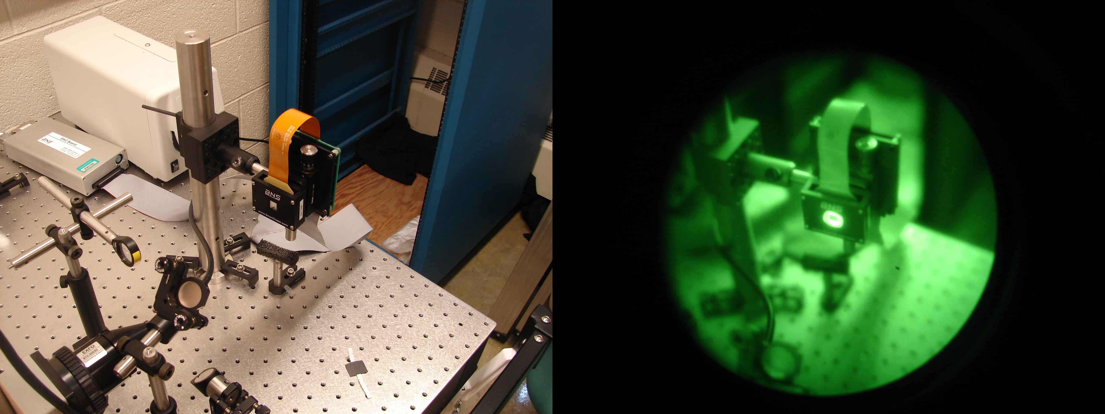

Laser and Power Supply
Manual Shutter
Laser ON/OFF Key
Power Switch

Motorized Stage, Joystick and Proscan II Controller
Speed Select Button

IR Viewing Scope and Card
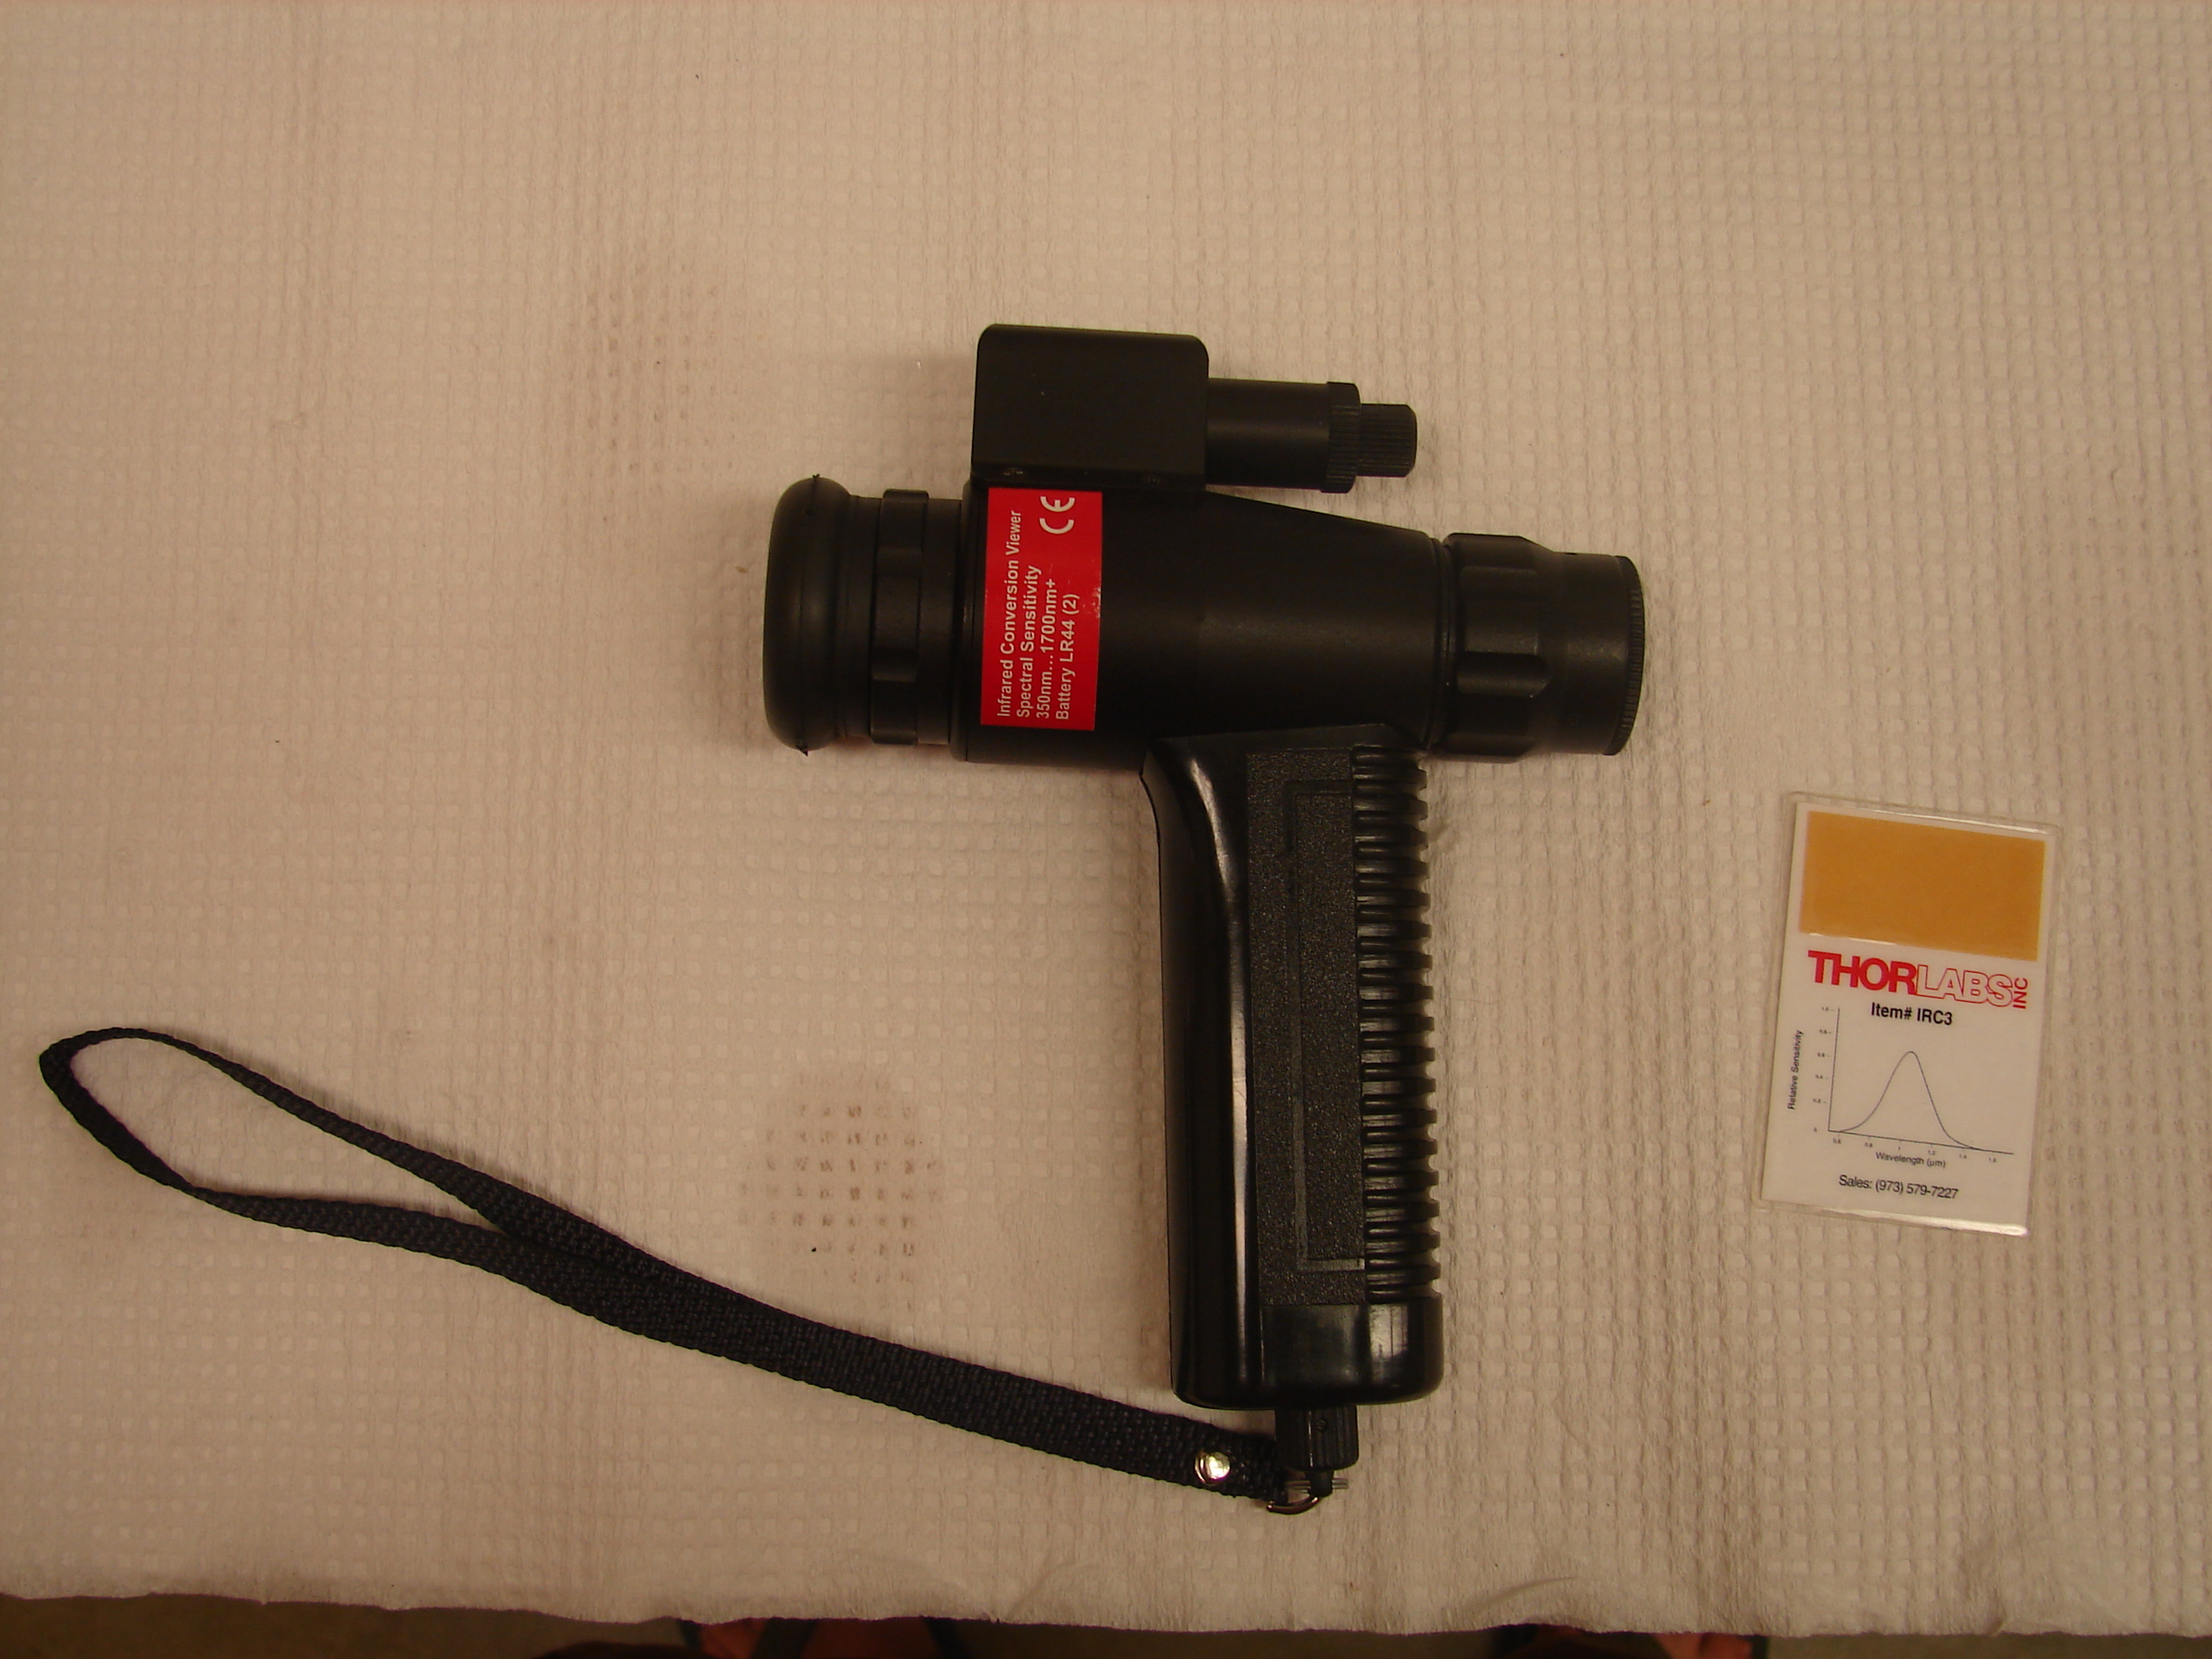

Getting Started

Power on the Stage
Switch on the power to the stage at the control box. You may now manipulate the stage using the joystick. The speed can be controlled using the button on the left of the joystick. Pressing once will change it to 50% speed, a second time to 25% speed and then a third time will return it to 100% speed.

Using the Microscope
Select the objective that you wish to use. For trapping the oil objective works the best. Carefully place the sample on top of the stage after applying any immersion oil or water to the microscope objective.

Turn on the microscope illumination with the power switch on the lamp control box. If you don’t see the light when you turn up the power check to make sure that the switch on the back side of the microscope is on.

Before you look through the eyepiece make sure that the laser is off, shuttered or check with the viewing card to make sure that no laser light is coming through the eyepiece.

Switch the lever on the lower left side of the microscope to the right to switch the view to the eyepiece. Turn up the brightness to an acceptable level and then select the filter you wish to use by the slide control directly below the objective lenses.

Adjust the focus until the sample is clear and in view.

Trapping
Switch on the laser power and wait a minute before turning the key to turn on the laser. Check the laser shutter is open using the viewing card.

Switch the lever on the lower left side of the microscope to the left to move the view to the camera.
Open the program Arryx LabRyx from the desktop shortcut. 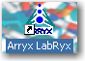

Adjust illumination and focus until the view on the computer screen is clear.

Create traps by selecting the control and then clicking on the screen.

Move traps by clicking and dragging the trap with the control.

Delete a trap by selecting it so that it turns green and then pressing Delete. Pressing Ctrl-Delete will delete all traps.

Advanced Operation

Computer Control of Stage
The control panel for the stage generally opens automatically with Arryx LabRyx but if it does not it can be opened by clicking on LabRyx Stage Control Addon.vi in the settings tab in LabRyx.

The stage must be powered on before opening LabRyx. If it is not then communication with the control may be established by closing the control with the HALT command and then opening it from the settings tab.

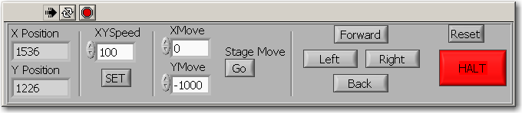
X Position and Y Position are in microns. Moving the joystick will not change the displayed values but they can be used as a reference for computer controlled movements.

XY speed is in μm per second. You must click on SET before a change to the speed will take effect.

XMove and YMove will move the stage relative to its current position. The units are μm and the command will be sent as soon as you click on Go.

Forward, Left, Right and Back will move the stage 1000 μm in the specified direction.

Reset will reset the speed to The maximum stage speed, but will only work after movement has stopped.

Halt will stop all movement and close the stage control.

Arryx LabRyx

Recording Video
Click on the “Settings” tab in LabRyx and beside the “Video Save Filename” header click the icon to browse for a folder and enter a filename. End the file name with 0001 and it will increment each successive video.

Selecting Microscope Objective
Under the settings tab there is a drop down window labeled “Objective in Use” which allows you to select whether you are using the oil or water objective. The parameters are listed on the side of the lens itself.

Manipulating Traps
The icon allows you to zoom in the video.

The icon allows you to move the view after you zoom in. It does not allow you to grab and move traps.

Traps are created, selected and dragged using the icon.

The ruler tool which has the icon will be of no use whatsoever as a design flaw in the program causes the length to be displayed off of the screen. Use the scale under the settings tab and then measure the pixels using ImageJ or another program after you have recorded your video.

The drop down menu at the top of the basic tab allows you to alter individual traps. Select the trap you wish to manipulate and then select the attribute from the drop down menu which will look like this: 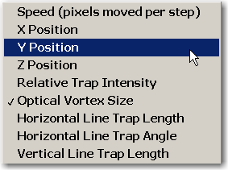
And then adjust the value using the long scroll bar just to the right and below the menu.

Speed, X, Y, and Z position are self explanatory.

Relative trap intensity matters if you have more than one trap and wish to distribute the power between the two. It doesn’t make a difference if there is only one trap.

Horizontal and Vertical Line traps are useful for trapping objects which are not round.

