Making Microfluidic Devices: Protocols Manual

Safety

Wear safety glasses, mask, gloves.

All the spinning and developing processes should be performed in the fume hood.

Keep the hood blower on all the time.

Waste chemicals should be placed in the waste chemical container.

Equipment Checklist

Spin coater

Vacuum compressor

Two hotplates

UV light curing system

Plasma Cleaner (found in Chemistry Department)

Supplies and Chemicals Needed

Petri dishes

3 inch Silicon wafer(s)

SU-8 photoresist (found under the hood)

SU-8 developer (found in Flammables cabinet)

Sylgard 184 silicone elastomer and curing agent

Geltest trichlorosilane

Isopropanol

Acetone

Background

Microfluidics emerged as a technique in the early 1980s. It is now widely used in the development of microdevices. A microfluidic device should have one or more channels which have dimension smaller than 1 mm. Common fluids used in microfluidic devices include blood samples, bacterial cell suspensions, protein solutions and various buffers. Microfluidic devices can be used to measure molecular diffusion coefficients [1], fluid viscosity [2], pH [3], and enzyme reaction kinetics [4]. Other applications for microfluidic devices include capillary electrophoresis [5], immunoassays [6], flow cytometry [7], sample injection of proteins for analysis via mass spectrometry [8], DNA analysis [9], cell manipulation [10], cell separation [11], cell patterning [12] and many other applications that fall under the rubric of “Lab-on-a-Chip”.

Making a pattern

The first step in any microfluidics application is to come up with a pattern. This can be designed in any paint or drawing program and then printed on a plastic sheet. This sheet will be placed on top of a silicon wafer to create the pattern that will be etched into silicon. A look at some of the references above or other papers from the literature should give you ideas on patterns that could be generated. The pattern should have a goal in mind. E.g. you could look at diffusion in the channel or at particle flow or particle sorting at bifurcations. Optical tweezers could also be used.

Section 1: Etching substrates with photolithography to make a pattern

We use chemical etching method to remove layers from the surface of a wafer, leave the pattern what we want. The detail steps are following,

1. Substrate Pretreatment
Before using the silicon wafer substrate, it needs to be cleaned and dried. Start with a solvent cleaning or a rinse with dilute acid, followed by a DI water rinse; dehydrate the surface by baking at 200 °C for 5 minutes. If the wafer is cleaned already, we can just blow it with air, and then continue to the next step.
Substrate Pretreat
Spin Coat
Soft Bake
Mask & Exposure
Post Exposure Baking
Develop
Rinse and Dry
Hard Bake (optional)
PDMS
Removal (optional)

2. Spin Coating with SU-8 photoresist
SU-8 2010 is the photoresist that will be used. Turn on the compressor and the spin coater, switch on the control and vacuum till these two lights up.
(a) To adjust the spin speed, set the low speed (Speed I) and high speed (Speed II) times (Timer I and Timer 2) to 30 sec. Press the “Start” button and adjust Speed I to 500 rpm. When the spin coater switches to high speed, adjust Speed II to 1000 rpm.
(b) For centering the wafer, change Timer I to 5 sec and Timer II to 3 sec.
(c) Put a cleaned wafer on the spin chuck. Turn on the spin coater, see if the wafer is rotating about its center. If not, turn off the vacuum, adjust it a little bit, turn on the vacuum and test it again. Repeat the adjustment till the wafer is in a good position (i.e. when it is not shaking too much).
(d) For coating with photoresist, set low speed Timer 1 to 5 sec and the high speed Timer II to 30 sec.

When all the adjustments are set, measure about 3.5 ml of the SU-8 photoresist into a centrifuge tube. Pour all the photoresist onto the center of the wafer. Check that the pump is on, and the vacuum and the control lights on the spin coater are on. Cover the spin coater with the lid. Press the “start” button on the spin coater and close the hood.

Generally, we can divide it into three stages.

(a) Static Dispense: 1 ml of resist per inch of substrate diameter

(b) Spread Cycle: Ramp to 500 rpm at 100 rpm/sec acceleration, then spin for 5 sec.

(c) Spin Cycle: Ramp to final speed at an acceleration of 300 rpm/sec and hold for 30 seconds. The final speed should be 1000 rpm/sec.

Wait until the spinning process is done. Turn the vacuum off, take the wafer off the spin chuck with tweezers.

3. Soft Bake
After the photoresist has been coated on the wafer surface, it must be soft baked to evaporate the solvent and densify the film. Using the first hotplate to prebake it at 65°C for 1 min, and then use the second hotplate to bake it at 95°C for 3 min.

4. UV Exposure for curing Photoresist
Put the mask on the coated wafer, use the weight to hold the patterned mask you developed beforehand that has the pattern you want to create and put them into the Electro-Lite ELC-500 UV light exposure system. Make sure the pattern is located in the center of the wafer and not covered by a weight. Set the time to 0.9 min and press “start”. This step will expose the parts of the photoresist that are not covered by a black line on the pattern.

- Post Exposure Baking (PEB)
After the exposure, we have to bake it. The post-exposure baking (PEB) selectively crosslinks the exposed portions of the film. Bake it at 65 °C for 1 minute on the first hotplate, and then bake it at 95 °C for 2 minutes.

- Develop
SU-8 2000 resists have been optimized for use with MicroChem’s SU-8 Developer. Immerse the wafer in developer for 15 seconds. Rinse it with isopropyl alcohol (IPA) for 15 seconds, repeat the development again and then rinse it into acetone. The last step is to rinse it with water and dry it with a gentle stream of air.

- Hard Bake (cure) (optional)
Bake the etched wafer at 150-200 °C for a few minutes.

This pattern should produce a raised pattern on the silicon wafer. This could be imaged under an inspection microscope or on the SEM. The figure below shows an etched wafer.
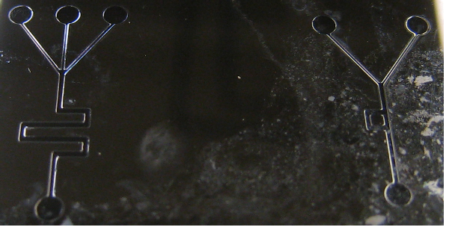

Section 2: Casting the flexible device on the silicon pattern

In this chapter, we will produce a polydimethylsiloxane (PDMS) cast of the pattern on the etched wafer that was produced in the previous section. The pattern can be used to make many copies of the device.
Prepare the PDMS
De-bubble
Bake at 70°C
Cut the sample
Punch holes

Prepare the silane
Seal the sample with plasma

1. Prepare the PDMS
Use the Sylgard 184 silicone elastomer (Dow Corning Corp.) to make the PDMS we need. The ratio is 10:1 (35ml of Sylgard polymer with 3.5 ml of curing agent).
Mix the polymer and curing agent well in the cup.

2. Prepare the Geltest trichlorosilane (silane)
Use a pipette to put 200 µl of silane in the lid; It will evaporate slowly.

3. Debubble
Put the wafer, the PDMS and the silane into the vacuum chamber. Turn on the compressor, make it vacuum for 30 minutes. Most of the bubbles will disappear.
Take the lid out the chamber, leave it in the hood.

4. Casting
Place the wafer into the Petri dish and pour the PDMS onto the wafer. Put the Petri dish into the vacuum chamber and pump it down for about 30 minutes until all bubbles disappear.

5. Baking
Take the dish out of the vacuum chamber and bake the dish on a hotplate at 70 °C for 70 minutes, check its strength by poking it with a probe.

6. Cutting out the pattern

Use a scalpel or razor blade to cut a square section that includes the pattern out of the cured PDMS. Once the scalpel touches the wafer and air comes in, stop going deep. After you cut the outline of the square, take the square section out gently. Put the sample onto a clean microscope slide. The face with the channels should attach to the slide.

7. Punch holes

Use a hollow needle to punch holes into the inlets and outlets of the sample. Keep the needle upright while punching holes. Push the needle a little hard and make sure it touches the slide.

8. Seal the sample.

Put a cover coverslip and the sample into a Petridish, take them to the chemistry lab. During the process, don’t touch the sample surface and the coverslip with your fingers. Use forceps to pick everything up. Keep them clean all the time. Use the Plasma Cleaner. First, Clean the Plasma Cleaner with a paper towel then put the coverslip and the sample into the Plasma Cleaner. Close the lid, turn power on, screw in the valve and turn on the vacuum. After 10 seconds, turn the plasma on, switch to medium level and wait for 30 seconds. Turn the vacuum off, turn the plasma off, turn the power off and release the valve slowly. Until there’s no air coming into the Plasma Cleaner, take off the lid. Take out the cover slip and the sample. Use the coverslip to seal the channels. Wait 20 minutes, you will see, the air between the PDMS and the coverslip will disappear slowly.

After all the air is gone, the sample is ready to use. Keep it in a Petri dish for future use.

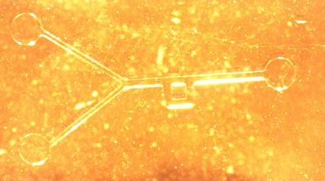

This is a sample without punching hole. The illumination is from top with black background .

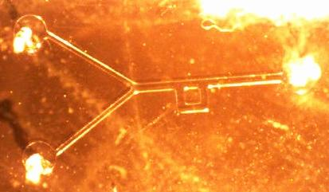

This is the sample after punching. The white dots are those holes.

It is illuminated from top with black blackground.

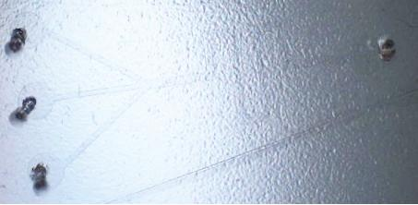

This is another design. The sample has been punched with four inlet and outlet holes and illuminated from top. The background it white.

Section 3: Application ideas and Summary

With the microfluidic device, we can do some microfluidic experiments. The following figures show devices made by Ido Braslavsky’s Ph.D. student Yangzhong Qin who made the devices in Summer 2008. The first device has two inlets and one outlet. He inserted tubing into the inlets and outlets. With two syringes, he injected red and green liquid from each of the inlet. It shows that the liquid in the channel moves in only one direction. Once the channel is tiny, the diffusion is negligible. This doesn’t like the macro liquid which can easily diffuse.

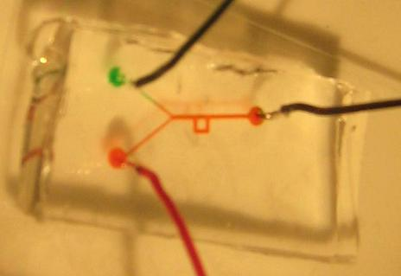
The figure above shows the overall view of the device and plumbing. Injections are green and red food dye. In the figure, the red liquid had high pressure and took up the whole channel.
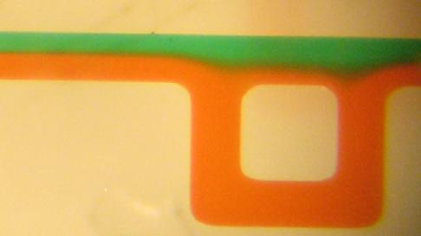
In this picture, we can see that two different color liquid flow in the same channel, but they don’t diffuse into each other obviously, except in the junctions of the chamber.
Reference:
1. Kamholz, A. E., Schilling, E. A. & Yager, P. Optical measurement of transverse molecular diffusion in a microchannel. Biophysical Journal 80, 1967-1972 (2001).
2. Galambos, P. Ph.D. Thesis, Mechanical Engineering. University of Washington, Seattle (1998).
3. Weigl, B. H. & Yager, P. Silicon-microfabricated diffusion-based optical chemical sensor. Sensors and Actuators B-Chemical 39, 452-457 (1997).
4. Duffy, D. C., Gillis, H. L., Lin, J., Sheppard, N. F. & Kellogg, G. J. Microfabricated centrifugal microfluidic systems: Characterization and multiple enzymatic assays. Analytical Chemistry 71, 4669-4678 (1999).
5. Kameoka, J., Craighead, H. G., Zhang, H. W. & Henion, J. A polymeric microfluidic chip for CE/MS determination of small molecules. Analytical Chemistry 73, 1935-1941 (2001).
6. Hatch, A. et al. A rapid diffusion immunoassay in a T-sensor. Nature Biotechnology 19, 461-465 (2001).
7. Sohn, L. L. et al. Capacitance cytometry: Measuring biological cells one by one. Proceedings of the National Academy of Sciences of the United States of America 97, 10687-10690 (2000).
8. Gao, J., Xu, J. D., Locascio, L. E. & Lee, C. S. Integrated microfluidic system enabling protein digestion, peptide separation, and protein identification. Analytical Chemistry 73, 2648-2655 (2001).
9. Fan, Z. H. et al. Dynamic DNA hybridization on a chip using paramagnetic beads. Analytical Chemistry 71, 4851-4859 (1999).
10. Glasgow, I. K. et al. Handling individual mammalian embryos using microfluidics. Ieee Transactions On Biomedical Engineering 48, 570-578 (2001).
11. Yang, J., Huang, Y., Wang, X. B., Becker, F. F. & Gascoyne, P. R. C. Cell separation on microfabricated electrodes using dielectrophoretic/gravitational field flow fractionation. Analytical Chemistry 71, 911-918 (1999).
12. Folch, A., Jo, B. H., Hurtado, O., Beebe, D. J. & Toner, M. Microfabricated elastomeric stencils for micropatterning cell cultures. Journal of Biomedical Materials Research 52, 346-353 (2000).

