**PHYS 372 – Brownian Motion and Optical Tweezers**

**1. Introduction to Optical Trapping**

Optical trapping using a device called Optical Tweezers or Laser Tweezers was developed in the 1980s from work on laser trapping of atoms. It was realized that a focused laser could be used to trap and manipulate micrometer-sized particles (dielectric objects) with index of refraction different from their surrounding medium (e.g. cells, latex beads in water). These trapped particles can then be used as handles to stretch DNA, control molecular motors or study adhesion molecules.

In this lab you will be learning to use an Optical Tweezer system and particle tracking software. You will measure the diffusion from the Brownian motion of <2 µm beads in a liquid and use this to calculate Boltzmann’s constant. Then you will measure the strength, or stiffness, of a trap made by the Optical Tweezer. By the end of this lab you should:

* Have a basic understanding of the fundamentals of optical trapping.
* Have a basic understanding of the fundamentals of particle tracking.
* Be able to explain Brownian motion and Diffusion.
* Calculate Boltzmann’s constant.
* Be able to explain trap stiffness and to calculate it.

**2. Theory**

**2.1 Brownian Motion**

Before you can use the laser trap, you must familiarize yourself with the use of the optical microscope. You will do this by observing the Brownian motion of 2 µm beads in water. This motion was observed by microscopist Robert Brown in the 1820s when he was observing pollen grains and he managed to demonstrate that this motion was not the result of the particles being alive. It was observed for any sufficiently small particle.

The origin of this motion remained mysterious until 1905 when Albert Einstein (as part of a project to identify practical consequences of the atomic hypothesis, which was at that time still unproven) predicted that micrometer-sized particles should move significantly when viewed under the microscope thanks to random atomic collisions that change the direction of travel. These collisions can be thought of as a ***random walk***. At each step in the walk, the molecule travels in a new random direction. Einstein was apparently unaware that Brownian motion had been observed by biologists but from general arguments he predicted it should exist for both small molecules and larger particles.

By analyzing the random walk he found that for diffusion in one dimension (i.e. back and forth along a line or inside a pipe), the mean square displacement of dye molecules or small particles, <*r*2>, as a function of time was related to the diffusion coefficient, *D* (from Fick’s Law for diffusion; the units of *D* are m2/s) by the relation:

*<x2> = 2Dt.* (1)

For a random walk in 2-dimensions (which is what we see under the microscope, we note that *r*2= *x*2 + *y*2, and when we take averages (indicated by angle brackets), <*r*2> = <*x*2> + <*y*2>. But since x and y are independent 1-D axes, <*x*2> = <*y*2>, so <*r*2> = 2<*x*2> = 2(2*Dt*). We thus have that:

** (2)

You will observe 2-D diffusion under the microscope.

Einstein’s analysis of the random walk also led to a relation between the diffusion constant and Boltzmann’s constant:

 (3)

Here, *k*B is Boltzmann’s constant, *T* is the absolute temperature (in Kelvin), ** is the viscosity (the viscosity of water at room temperature is 0.00100 Pa s) of the fluid surrounding the particle and *r* is the radius of the diffusing particles (this can range from nanometers for molecules to a few micrometers for small dust particles or cells).

In 1908, Jean Baptiste Perrin, a physicist working at the Sorbonne in Paris did experiments that measured Brownian Motion of particles and used Einstein’s random walk theory to find a value for Avogadro’s number (the number of atoms in a mole, a term Perrin evidently coined). Perrin observed 2-dimensional Brownian motion of tiny latex particles in water at 20°C under a microscope. The particles had a radius of 0.37 m. Perrin observed the position of a particle, waited 30 s, then observed again and plotted the net displacement in that time interval. He collected 500 data points in this way and found that for these particles, the root mean square displacement <*r*2> was 7.84 µm for all of the 30 s long time steps. Using this data, there are three steps to the estimate of *N*avogadro

* For 2-D diffusion, <*r*2> = *4Dt*, so the diffusion constant can be calculated from *D =* <*r*2>/*4t* = (7.84 x 10-6 m)2/(4 * 30 s) = 5.12 x 10-13 m2/s.
* Once D is known, Einstein’s theory says that *D* = *kBT*/(6*r*). We can rearrange this to find an estimate of Boltzmann’s constant *kB* = 6*rD*/*T*, so *kB* = 6**(0.001 Pa s)(0.37 x 10-6 m)(5.12 x 10-13 m2/s)/(293 K) = 1.22 x 10-23 J/K.
* Recall that the kinetic theory version of the ideal gas law constant requires that *R* = *N*avogadro *kB* (*R* had been measured long before through the Ideal Gas Law, *pV* = *nRT*). One can thus calculate Avogadro’s number from *N*avogadro = *R*/*kB*. Putting numbers in, we get *N*avogadro = (8.314 J/mol/K)/(1.22 x 10-23 J/K)= 6.81 x 1023 molecules/mol.

The value that Perrin found for Avogadro’s number (a term he coined in his book “Brownian Movement and Molecular Reality”) was surprisingly close to values measured using completely independent methods suggested by Einstein and other pioneers of quantum mechanics. The concordance of the different independent values for this important number sealed the case for the atomic hypothesis, which up until then had been considered an unproven (if useful) hypothesis.

The Perrin value was refined using similar methods to 6.02 x 1023 by 1914. This is close to the modern value based on extremely precise experiments using the atomic structure and spacing from X-ray crystallography to calculate the number of atoms in samples of known volume and mass (6.0221415 x 1023 ± 0.000 0010 x 1023 mol-1). In 1926 Perrin won the Nobel Prize for Physics for his “work on the discontinuous structure of matter” (i.e. the confirmation of the reality of the atomic hypothesis).

**2.2 Optical Trapping**

Dielectric particles are affected by both scattering and gradient forces when they are exposed to light beams. The scattering component is the photons pushing on the object (we think of that as the radiation pressure). The gradient force is a force experienced by dielectric objects in an inhomogeneous electric field (e.g. in a light beam whose intensity decreases with distance from the center as in most laser beams). The force, in this case, points in the direction of the field **gradient** (see Neuman and Block 2004).

A full treatment of the trapping mechanism is nontrivial, but a simplified argument for objects larger than the laser wavelength (in this case, 1064 nm) using ray optics and momentum transfer is shown in Fig. 1. When there is a gradient in light intensity (as one finds in a Gaussian laser beam), light momentum change from before to after refraction for rays nearer and further from the beam center leads to a net force on the particle that points toward the center of the beam. This provides the trapping force in the viewing plane. There is also a force towards the beam focus which provides the trapping force perpendicular to the viewing plane. The trapping force is, thus, a restoring force that returns the particle to an equilibrium position if it should be displaced. For small displacements, *x* (e.g. due to Brownian motion), the force follows Hooke’s Law with   
*F*trap = –*k*spring *x*.

.

**Fig 1.** For objects larger than the laser wavelength the trap can be explained using ray optics. From Newton’s 3rd law the change in momentum as the ray enters and exits the bead forces it back to the focus of the beam.

Beam Intensity

Force

in

out

change

Beam Intensity

Force

To get a large gradient in intensity, an infrared laser beam is directed through the objective lens of a microscope. One needs to use a high Numerical Aperture (NA) lens (NA = *n* sin ** where *n* is index of refraction between sample and objective lens and ** is half angle of light captured by objective lens). If there is not a large enough gradient the scattering forces will push the object out of the trap.

You can think of the trap as a potential well with a stiffness *k*trap. We imagine we have three springs for our trap with *k*x, *k*y, and *k*z. If our optics were perfectly aligned then *k*trap,x and *k*trap,y would be the same. There are a number of ways to measure trap stiffness.

* One can measure the displacement of a trapped bead when the fluid is moving with respect to it, creating a drag which we can calculate given the viscosity of the fluid and the size of the sphere. At low speeds the drag on a bead is *F*drag = 6*rv*. ** is the viscosity, *r* is the radius of the sphere and *v* is its velocity with respect to the medium.
* Another method looks at the power spectrum of position fluctuations from the Brownian motion. Basically the frequency that it moves. To understand this method we look at the equation for a particle in one dimension in a viscous fluid while combined to a potential well () which is:

 (4)

We have left out the inertial term () because the drag term (γ) dominates. Because *Frandom(t)*, the fluctuating force on the bead (Brownian motion), averages to zero we must solve this using the Fourier transform and we get:

 (5)

Where *T* is the temperature, *f* is the frequency, *k*B is Boltzmann’s constant and γ is the drag coefficient (= 6*r*). *f*c is the corner frequency and is defined as:

. (6)

From the corner frequency we get the spring constant. The advantage to this method is that we get a precise value for the trap stiffness from the frequency of the position fluctuations. All you need is a very fast and accurate way to track the position of the beads.

* The method we will use is more susceptible to low frequency noise but that is conceptually simpler and more direct. From the Equipartition theorem we know that the energy will be *½kBT* times the number of degrees of freedom, which is one degree in our case as we are breaking it down into components. Therefore since we are assuming a harmonic potential we can say:

 (7)

Where *U*(x) is the potential energy and *x*0 is taken as the center of the trap.

**3. Experimental Setup**

Diagram for the laser setup (see article by Lee at al. 2007 Nature Protocols in References)



IMAGE1

Filter

Camera

IR Laser

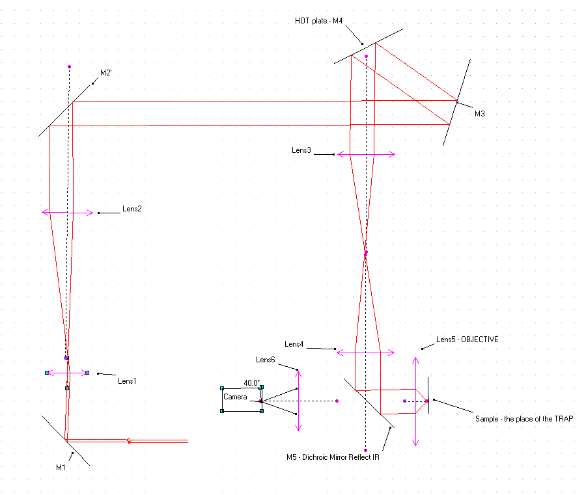

**3.1 Laser**

The laser you will use is an infrared diode laser with a power of 800 mW. When the beam is aligned, protective eyewear is not required. During alignment, however, you must wear the protective eyewear provided. NEVER LOOK DIRECTLY INTO THE LASER BEAM. The infrared light is not visible to your eyes so damage could occur without your being aware of it. **Serious damage to your eyesight or blindness could occur!** If you wish to trace the beam path, use the sensor strip that makes the infrared light visible

**3.2 Filters**

You can control the strength of the trap by changing the laser intensity with filters. You may start out with no filter and then try the two filters to see how they affect your trap. When the IR laser beam passes through a filter it reduces its intensity (by factor of 10ND, where ND = 0.6 or 2).

**3.3 Beam Expander**

The narrow, collimated beam that comes out of the laser is reflected by mirror M1 towards lens L1 (*f* = 35 mm) and lens L2 (*f* = 200 mm) that together expand the diameter of the beam by a factor of 200/35. This allows the laser to fill up the square window you see on the HOT plate. Mirrors M2, M3a and M3b direct the beam towards the HOT plate, which serves as mirror M4.

**3.4 Holographic Optical Tweezers (HOT) Spatial Light Modulation (SLM) mirror**

Multiple laser traps can be created and manipulated using a state-of-the-art Holographic Optical Trap plate made by Arryx Inc. ([www.arryx.com/PDFdocs/optical_trapping.pdf](http://www.arryx.com/PDFdocs/optical_trapping.pdf)). This plate contains a material whose refractive index can be modified so that it acts as a localized mirror at a number of spots. This sophisticated mirror can make multiple output beams from a single input laser beam.

**3.5 Telescope**

The beam is reflected from the HOT plate (M4) towards Lens L3. The light is focused into the plane labeled IMAGE1. This plane is imaged into the sample by lenses L4 and the objective L5. In earlier optical tweezer setups Lens 3 was moved to control the movement of the actual trap instead of using a HOT plate.

**3.6 Dichroics**

A dichroic mirror will reflect some light wavelengths and pass others. Here reflecting IR and passing visible light.

**3.7 Microscope and Illumination**

An essential component of the Optical Tweezers setup is the optical microscope. This is used to focus the laser beam into the specimen plane where a bead sample is placed for viewing. A traditional **upright microscope** is shown in Fig. 3b. Light from a lamp below the stage passes upwards through the sample (where differences in index of refraction in the specimen create contrast). An objective lens then creates an image that becomes the object for the eyepieces.

Most modern microscopes, however, now use the **inverted** geometry shown in Fig. 3a. Light is generated by a lamp above the specimen plane and then passed downward through the specimen before being collected by the objective lens. The image from the objective is then used as the object for the eyepieces.

|  |  |
| --- | --- |
| Microscope | Upright Microscope Ido's lab |
|  | lamp |
| Figure 3a. Inverted optical microscope | Figure 3b. Upright optical microscope |

The microscope you will be using is an **inverted microscope**. There are two ways to bring in the light. In trans-illumination (Fig. 4a), the light passes through the sample. In epi-illumination (Fig. 4b), light comes in from below the sample and is focused up through it using a dichroic mirror that reflects light of a range of wavelengths (e.g. infrared light) but allows other wavelengths (e.g. visible light) to pass through. In this experiment, the visualization will be done using trans-illumination, but the laser beam for the trap will be brought in using epi-illumination.

|  |  |
| --- | --- |
|  | lamp |
| Figure 4a. Trans-illumination | Figure 4b. Epi-illumination |

The important parts of the microscope are shown in the figure below. The microscope **lamp** is turned on using the button on the lamp control box (off the table). The viewing chamber is placed on the **stage** of the microscope. The **objective** lens (there are several of these mounted in a turret) can be moved up and down using the coaxial **coarse focus** and the **fine focus** control knobs. These controls are used to produce a sharply focused image of particles in the viewing chamber. The viewing chamber can moved by moving the stage top using the coaxial **x-y stage control** knob so that objects can be moved into the center of the field of view.

The controls above are the major ones that you will use. Several other controls are also important.

1) The **output selector** switch controls whether light goes to the eyepieces (so that you can see the sample directly) or to the video camera (so that images can be captured to the computer). For reasons of safety, it is better to not look through the eyepieces when the laser is on.

2) **Condenser lens adjustment**. The position of the condenser lens has a significant effect on image quality. In general, it should be set by the instructor and not moved. It is set correctly when the image of the field aperture diaphragm is in focus in the image at the stage.

Field aperture diaphragm

|  |  |
| --- | --- |
| Figure 5. Nikon TE200 inverted optical research microscope. | Microscope  Condenser lens adjust  **Output selector**  **Coarse**  **focus**  **x-y**  **stage control**  stage  **Fine**  **focus**  objectives  Eyepieces  lamp |

**4. Methods**

**4.1 Prepare Sample**

Your first sample will be 1.5 µm-diameter silica beads suspended in a “buffer” at a .01% by volume concentration. A buffer is a solution of a number of different salts dissolved in water. The salts mimic those that are present in biological tissues and they are chosen so that they can absorb small amounts of acids or bases without changing the overall pH of the solution (hence the term “buffer”).

The silica beads are made by Bangs Laboratories (Fishers, IN) one of the major manufacturers of high quality monodisperse micro particles. They come from the factory at high concentration. If these beads were place directly into the viewing chamber they would be far too concentrated (1% by volume) and it would be hard to see anything. The beads first need to be diluted

A dilution is normally done in two steps. In the first you take out a sample of beads from the bottle that came from the factory. This first dilution will have been done for you already. 5 µl of the original bead suspension has been pipetted into 45 µl of buffer to do a 10 fold dilution. This suspension will be in a 1.5 ml Eppendorf micro tube labeled "bead first dilution".

* Using the 1-20 µl pipette, put 3 µl of the bead first dilution into a new Eppendorf tube. Make sure that every time you use the pipette you put on a new tip!
* Using the 100-1000 µl pipette, add 297 µl of buffer solution to the 3 µl of bead first dilution to get 300 µl of bead second dilution. This procedure will result in a further 100 fold dilution so that the beads are now 1000x less concentrated than when the arrived from the factory. Label it. This should be adequate for viewing.
  1. **Viewing Chamber Construction**

Viewing Chamber

Make a chamber using two cover slips and double sided tape. Wear gloves while you do this (this protects the glass from oil on your fingertips) and take care. If your chamber is poorly constructed the fluid can leak out causing a drift as well as drying out your sample. Air bubbles inside may act like springs causing other fluctuations.

* Take a square microscope cover slip, lay it on a microscope slide and apply the two strips of tape to it leave a narrow gap (approximately 1 mm) between the two strips of tape. Cut your tap a little long so that a few extra millimeters hang over each end to help it stick to the stage.
* Place the round cover slip on top of the gap and make sure that the slip is firmly stuck by rubbing it with a pen cap or the tip of the metal forceps. By looking at the cover slip obliquely you can see any air gaps between the slip and the tape; you should rub until no such gaps remain. Be careful not to create small cracks in the slide.
* Pipette 5 µl of bead suspension and place a drop at the edge of the gap between the pieces of tape. Bead suspension will move in by capillary action. If you are careful you will pipette just enough to fill the chamber without excess or big air bubbles. If there is some excess liquid, it can be absorbed using a Kimwipe, but be careful not to absorb any of the liquid in the chamber.
* Seal the ends with clear nail polish and then leave to dry. Take care if you pick up the slide early as the acetone in the nail polish can soften the tape and cause the top slide to slip when touched.

**4.3 Using the Immersion Objectives**

The microscope you are using has several objective lenses to choose from. The 10x, 20x and 40x objectives require no immersion oil or water—they are intended to have air between them and the viewing chamber. You can use those for locating the viewing chamber.

The two objectives you will be using for optical trapping will be either the oil 100x or the water 60x objectives. One uses an immersion objective to increase the index of refraction between the objective and the sample and hence to achieve a higher numerical aperture (NA). The NA value for each lens (when the appropriate immersion fluid is used) is written on the lens.

The water objective has a smaller NA than the oil objective. You will, however, be able to see deeper into the sample than you could with the oil objective and have a wider field of view. Make sure that you do not get oil on the water objective! Keep in mind that any slide used previously on the oil objective has oil on it and you cannot clean it well enough for reuse; if you change from oil immersion to water immersion, you will have to use another chamber.

* Make a viewing chamber with the 2 µm beads that you mixed previously. Ensure that the beads are well dispersed in the buffer before you pipette them into the slide by vortexing the vial or flicking it with a finger.
* Remove any previous chamber. Label the chamber (using a Sharpie marker) and place on a slide in case you wish to work with it again later.

**For the Water objective**

It is very important to only put pure water (from the tube supplied) on the water objectives. Do NOT use tap water. Keep in mind that once a slide has been used on the oil objective you cannot place it on the water objective. You should not put anything on the air objectives.

* Lower the microscope objective lenses with the focus knob. Rotate the 60x water objective into place.
* Pipette 40 µl of water onto the water objective.

**For the Oil Objective**

It is very important to only put the supplied immersion oil on the oil objective (not any other kind). Keep in mind that once a slide is used on the oil objective you cannot place it on the water objective. You should not put anything on the air objectives.

* Lower the objective lens with the focus knob. Rotate the 100x oil immersion objective into place.
* Before you do anything else double check that you have the oil objective under the stage.
* Open the immersion oil which should be on the table next to the microscope. Uncap the oil dropper and, without touching the objective, allow ONE drop to fall on the center of the oil objective.

**After placing immersion fluid:**

* Carefully place the chamber on the microscope stage and then raise the oil objective until you see the oil spreading out on the slide. Look at the video and continued to raise the objective (UP is indicated above the focus dial) until the particles come into focus.
* The image analysis in RyTrack works best if the beads that are being tracked have BRIGHT CENTERS. Focus should be adjusted to make this so.

**4.4 Using LabRyx**

LabRyx is a computer program designed for use with the Arryx Holographic Optical Trap to allow you to create and move traps. Multiple traps can be created and moved independently.

* Open LabRyx.exe by clicking on the icon on the desktop 
* Switch the output selector on the microscope to use the camera.
* Go to the **Settings tab** in LabRyx and check the Camera setting at the top. It should show “LabRyx DirectShow Camera Control.” Click on the **Camera tab** to see the camera settings. Click on the Video Format Settings button. Change the Size to 640x480. Next, click the (On) box next to the Frame Rate label to get this to not be greyed out. For an image size of 640x480, 70 fps should be possible (the higher it is, the better). Type 70 in the box below the slider. One can further reduce the size of the image to get higher frame rates. To get really high frame rates (say 500 fps), small areas can be captured using the PixeLINK Capture OEM program. For guidance on using this program, consult the lab supervisor.
* Go back to the **Settings tab**, select the objective lens that you are using, (either the 60x Water Objective or the 100x Oil 1.45 NA Objective).
* Further down the **Settings tab** click on the folder icon for the Video Save Filename (AVI) and create a folder with your name so you can create a starting video file capture0001.avi E:\Experiments\2011_Winter\YourNames\capture0001.avi. Video files you record will be entered sequentially into this file (with the number incrementing automatically. Make sure you annotate each file with what conditions were used to generate it in your lab notebook.
* It is also useful (to create illustrations of trap patterns or other things one would like to snap images of) to create fill in a similar starting filename in Image Save Filename (BMP) on the **Settings tab**: E:\Experiments\2011_Winter\YourNames\Snap0001.bmp.
* Go back to the **Basic tab**.
* Switch on the power to the laser and let the power supply warm up for 10 min while you find the bead s in the viewing chamber. Make sure the laser control key is in the Off position and use the viewing strip to ensure that NO laser light is coming out. Only after the particles have been found and focused should the laser be turned on and the shutter opened. As a general rule, when one is not trapping (e.g. when adjustments are being made), the shutter should be closed and the laser key turned to the Off position.
* Adjust the focus and illumination until you find the beads. Once this is done, and any Brownian motion measurements have been made, the laser may be turned on.
* Make sure the blue dichroic is selected so that you can find the laser’s reflection on the glass. Find the bottom and top of the glass by adjusting the focus control until you see the reflection of the laser. **Make a note of the position of the glass by noting scale reading on the focus knob.**
* You will first have to Calibrate the traps. Click on the Calibrate Traps button. Labryx will display three spots. You have to click on the center of each of these spots and then press the Set Calibration Point 1 (2 or 3) button. Once this is done, LabRyx should be able to create traps.
* To create a trap, click on the button with a crosshair on the side of the video window and then click on the screen where you want the trap. There will be a residual trap in the center where the laser was and every time you make a new trap the trapping potential will be spread out between them. The default condition is that the laser power is shared equally among the different traps. It is possible, however, to adjust the relative intensities of the traps.
* Once the trap is created you should be able to trap particles at that location. Several particles may quickly snap into the trap. It is then a good idea to move the focus above the point where the particles are (the trap should move with the focus), remove any trapped particles by moving the stage controller so hydrodynamic forces push the beads out of the trap. One can then dip down with the focus and pick up a single bead for measuring trap strength. One can check that particles are trapped by blocking the beam and watching the Brownian motion of the particles increase. Restoring the bead should snap the particles back to the focus. If the particle is out of focus when it is held in the trap, it can be adjusted by changing the position of Lens 3 (see the Figure in Section 3).
* Move the focus to the middle depth of the viewing chamber and **cut off the laser**. Record a ten second video of beads in Brownian motion. You will use this to find Boltzmann’s constant. **Make sure to record the filename and image pixel size (e.g. 640x480).**

At this point you should be able to look through the eyepiece and adjust the focus and illumination until the beads are in view. Move the stage with the Joystick of the motorized stage control to move the beads over the center of the objective.

* Click on Record to capture video (or Save Image to save individual images). Take 10 second clips of a single trap then of two traps and then three traps. It doesn’t matter if other beads are in the screen, you can take them out when you extract the data later so long as there is only one bead in each trap. **Make sure that you write down the file names that you give them with the screen width.** It will also help to have the frames per second. You can also capture video of single particles in traps at different heights above the bottom cover slip. The trap strength should decrease with height and you can measure this.

**5. Data Analysis**

You will track particles from your images to find Boltzmann’s Constant from your clip of Brownian motion with no trap present. You will then calculate the x and y trap stiffness for one or more of the trap videos that you made. If you have time then calculate the trap stiffness from the multiple trap videos to see how they compare.

**5.1 Changing Your Video into TIFF Stacks**

If you captured the video using the PixeLINK OEM program, then you will already have a folder(s) full of images (aka a “stack” of images). If so, you can skip to Section 5.2 (although you should still look at the first image using ImageJ as described in below to get useful measurements).

If you recorded an AVI video file, then you will need to break it down into individual pictures. To do this you will use a program called VideoMach (a limited version of this program is available for free download). It will allow you to save your video as sequentially labeled images. ImageJ is a program developed by researchers at the National Institutes of Health to help with image analysis.

* Double click the  icon on the desktop to open VideoMach.
* Click on File>Open Media Files and browse to find the .AVI clip you want to analyze.
* Click on the icon with an “i” inside a blue dot 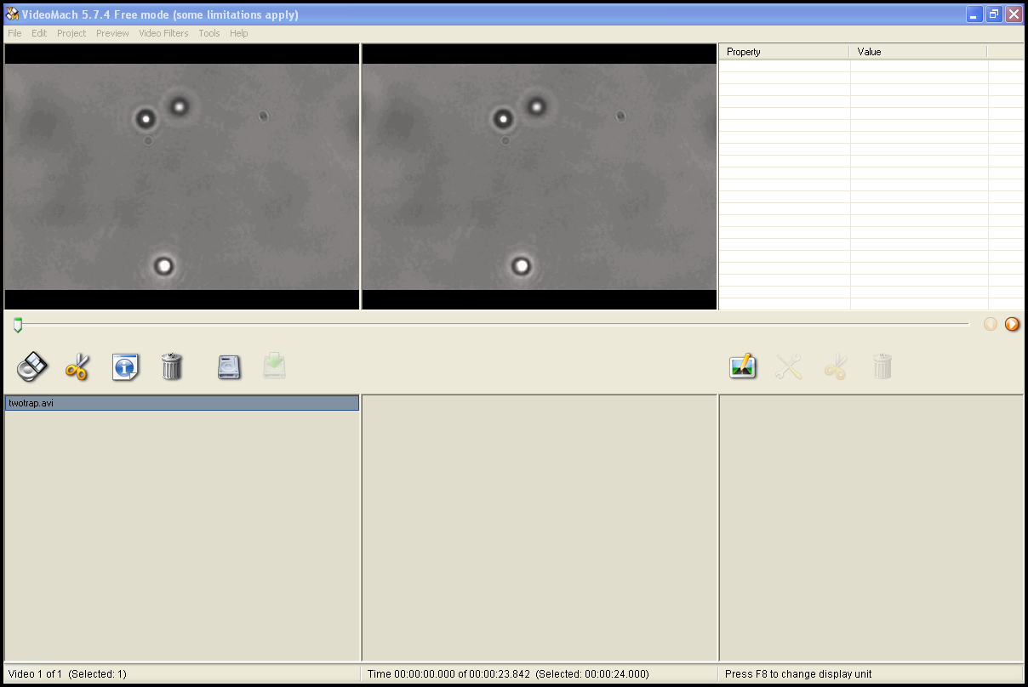 to get information about the video. **Write down the number of frames and the frame rate in your lab book (the frame rate is in frames per second or fps, even though the program does not give a unit). The time between frames (in seconds) is 1/frame rate.** You will need this later to get the time between each frame of video.
* Click on File>Save As
* Select Video Format – TIFF
* **Create a new folder inside your video folder** and select the file to write to as some appropriate variant of E:\Experiments\2011_Winter*YourName*\*Description*\image0001
* Click on the video tab and if the Color Depth settings are not already greyed out then deselect the color setting then select Grayscale to change the video to black and white.
* Click Save and VideoMach will save your frames as image00n.tif, where n is the frame number.
* Close VideoMach
* Open the first TIFF image in ImageJ to measure the diameter of the beads in pixels (this helps in setting up RyTrack) and also note the approximate pixel centroids for the particles you want to track (this will help you to identify the correct particle later in the output of RyTrack).
* Close ImageJ

**5.2 Tracking Your Beads with Rytrack**

Rytrack is a state-of-the-art, but somewhat temperamental GUI based particle tracking interface written by Ryan Smith of Gabe Spalding's lab of Illinois Wesleyan University. It uses a set of very comprehensive particle tracking routines written for the image analysis language IDL by John Crocker, Eric Weeks and David Grier. You will be using the full version of IDL to extract the data you need from the position and velocity data you get from Rytrack. If you would like to analyze programs on your own computer a compiled version of the program that works with the freeware version of IDL is available.

To use this program effectively, the focus of the microscope should have been adjusted so that the centers of the recorded particles were bright and not dark. If this was not done, then without further treatment the particles will appear as rings, and Rytrack will identify a number of spurious particles at various points around the ring. If the centers of the particles are much darker than the background, then it may be possible to click the box for a “negative image” but this is unreliable. If your files won’t analyze you may have to go back and collect new images.

To use Rytrack you will need to have some understanding of the various filters that it applies to your images. The filters are controlled by slider bars and you can observe the effects of the changes you make on frames from the stack of frames before you run the tracking routine. The following are the important filters and how to calculate the values you need for them.

* Image directory: This is where you enter in the location of the stack of images that you made earlier. It should be in the form E:\Experiments\2008_Winter*YourName*\*ObjectiveType*\*.tif
* Bandpass 1: The bandpass filter smoothes the image and removes the background. Bandpass 1 is the low end and is the length scale in pixels of noise in the image. You should set this to 1.
* Bandpass 2: This is the high end and should be set to a value a bit larger than the diameter of your beads in pixels. **It is very important that it be an ODD number**.
* Sobel Smooth: An edge enhancing function. You can leave this as is or see how adjusting it affects your image.
* Threshold: Pixels with intensities below the threshold value are set to zero (black) and pixels with intensities above threshold are set to maximum intensity (white). You will end up with a black and white image (rather than the previous grayscale image.
* Invert Image: Your beads must be white on a black background to track, if they are not, then selecting this option inverts the image to black on white. With appropriate re-thresholding this may remedy the problem. If it does not, then you will have to record new video.
* Particle Radius: “Radius” is a misnomer since it is (we think) actually the square of the radius of gyration. A reasonable approximation for this is to use the particle diameter (that you measured using ImageJ) and maybe add a few extra pixels. It can’t hurt to make this ODD as well.
* Particle Spacing: Defines how far apart two particles should be. Set it to your particle diameter in pixels plus 1.
* Mass Cut: This is one you can play with. The mass is the number of pixels that make up particles with some weighting by intensity (we think). Noise particles usually have small mass (<100). The particles we are interested in have a mass that is usually more than 700. Find a threshold that cuts out all the extra junk and keeps your particles.
* Eccentricity: This is how round or not round your particles are. It is best left alone since if you touch it, the program insists on your entering something. The only way to make it stop is to close the program and start again (we told you RyTrack was temperamental).
* Tracking Parameters: The following parameter will give the rules for which particles to keep once it has begun tracking.
* Maximum Displacement: Maximum number of pixels a particle can jump and still be the same particle. Generally you can just leave this one alone although if no particles are identified, you might try increasing it.
* Good Enough: This is important. It sets the number of frames that a particle must be in to be kept as a particle. Set it to about 3/4 of the number of frames you have. If no particles are identified then you might try reducing it.
* Steps Memory: Number of frames a particle can be missing and still be the same particle. Keep it low but it shouldn’t matter if you are filtering out any particles that aren’t there the whole time. If no particles are identified then you might try increasing it.
* Overlay Original: This will overlay the upper, original image with markers to show you what is being tracked. You should activate it and then observe how your changes affect the tracking.
* Overlay Filtered: Same as above, but it puts the markers on the filtered images. Generally it is best just to overlay the original as you might be missing something in the filtered image.
* Start: Click on this after you enter your filename into the image directory to bring up your images and start finding particles.
* ID and Track: Starts tracking particles once you are satisfied with your parameters.
* Just Track: Same as above if you have already run ID and track and just want to track.
* Close: What it says.

When you are correctly tracking beads you will see in the bottom right of the screen something like the following lines. If it gets hung up somewhere you may have to close the program and do it again. Make sure you record what parameters you used so that you can try to figure out which one messed things up, they will be in params.txt if you got that far. Most often, though, the program, if it is unsuccessful, the program will get to “Combining and sending to track” and then produce nothing (one can wait days and still nothing appears). The reasons for this are unclear and one wishes the program were more verbose about the reason for failure. For reasons that are mysterious, some files work perfectly well while others do not (often with the same parameters). You should collect several files, for this reason, and, most likely, one will work.

Feature and Track has started

E:\Experiments\2008_Winter*YourName*\*ObjectiveType*\001.tif

32 features identified [These two lines will repeat for each frame]

Combining and sending to track

30trackoutput.gdf has been written

trackoutput.dat has been written

params.txt has been written

Tracking Complete. If you are finished, press Close

32 elements found

32 elements retained

**5.3 Analyze Your Data**

If you look in the folder with the images you should now see a .gdf file for each image and then six new files. The important one is **trackoutput.dat**. You can right click on that and choose “Open With” to open it in Excel. You may also open the file with Wordpad or Notepad to see the output and if you know how to use Matlab, you can also import the file easily for analysis.

Once you have loaded your position data into Excel (or some other spreadsheet or calculation program). You need to analyze it. The columns in the file represent:

X centroid position of particle, in pixels.

Y centroid position of particle, in pixels.

Integrated brightness of the feature.

Square of the radius of gyration of the feature.

Eccentricity. This should be zero for circularly symmetric features (the kind that you are looking for) and order one for very elongated images (e.g. artifacts that represent spurious particles).

Frame number (for a given particle)

Particle number (there may be more than one of these—only choose the ones with a low eccentricity)

There may be more than one particle found. Find particles that have eccentricities close to zero (less than about 0.05) and copy the X and Y centroid coordinates to a new spreadsheet ply.

The X and Y data are in fractions of a pixel. One needs a scale conversion factor to convert pixels in micrometers. Ideally you should measure this yourself by capturing an image of the Stage Micrometer using the oil or water immersion lenses. The lines on the Stage Micrometer are 10 µm apart. Use an image analysis program to find pixel values for two widely spaced lines. You can then come up with a scale factor. If you do not have time for this, then for the 100x oil immersion objective you can use the value of 0.0592 ± 0.0001 µm/pixel. Use this or (preferably) your measured scale factor to convert the pixel values to micrometers.

5.6.1 Finding Boltzmann’s Constant from Brownian Motion with no Trap

In the introduction, we noted that for 2-D diffusion,

*,* (8)

with diffusion constant, *D*, given by the Stokes-Einstein relationship:

 (9)

According to these equations, if we can find mean square displacement for a given time step, <*r*2>, then we can find the diffusion coefficient, *D*. Once we have *D*, then we can find Boltzmann’s constant, *k*B, since we know the viscosity, **, of the suspending liquid (= 0.00100 Pa s in mks units for liquids like the buffer we use here that are based on water), the particle radius, *R* (you will need to measure this from your images) and the absolute temperature, *T* (**there is a thermometer in the room hanging from a string beside the whiteboard—you should note room temperature in your lab book**). If you have X and Y centroid values from *N* frames, then you can calculate *N*–1 displacements with a time step of one frame (= 1/frame rate, as noted above). You should square each of the displacements and then average them. This is very easily done using Excel or Matlab. You will then have the Mean Square Displacement (or MSD) for that time step of one video frame. You can also get N-2 displacements of 2 frames and N-n displacements of n frames and compute MSD for each of these longer time steps. One can then plot MSD vs time and one should get a relatively straight line, assuming that the motion is diffusive and not superdiffusive or subdiffusive (i.e. diffusion that does not obey Eq. 8 but instead follows <*r*2> = 4*Dta* with *a* greater than or less than 1). The slope will be 4*D*, and the intercept should be consistent with zero. If you get a kB value that differs substantially from the current best estimate, then it is likely that the diffusion had an exponent *a* that differed significantly from 1.

**5.6.2 Finding Trap Stiffness using Mean Square Distribution**

As noted in the introduction, we expect that for a particle in a harmonic potential (i.e. where the restoring force obeys Hooke’s law, we should get that:

 (10)

Note that we again have <*x*2>, a kind of MSD. Here, however, *x* is the displacement from the equilibrium position, *x*0. It is plausible to use the data to find the equilibrium position since the diffusion inside the trap should be centered on the equilibrium point. We will thus identify *x*0 = <Xcentroid> and *y*0 = <Ycentroid>. We can then use Excel or Matlab to subtract off the equilibrium values to get MSDX = <(Xcentroid – *x*0)2> and MSDY = <(Ycentroid – *y*0)2>. One can then use the equipartition theorem (Eq. 10) to get the spring constant (use the current best measured value for *k*B this time).

**5.6.3 Finding Trap Stiffness using Fourier Transform fitting**

As we noted in the introduction, another way to get the trap spring constant is to use Fourier Transforms. It can be shown that for a particle undergoing perfect Brownian motion in a perfect harmonic potential, the Power Spectrum (or Power Spectral Density), *S*(*f*) should have the form of a Lorentzian:

 (11)

Where *T* is the temperature, *f* is the frequency, *k*B is Boltzmann’s constant and γ is the drag coefficient (= 6*r* for a spherical particle, as is expected to be the case here). *f*c is the corner frequency which is defined as:

. (6)

It is fairly easy to calculate a Power Spectrum (although one has to be very careful about normalization—the theory above assumes that one is using a form of periodogram averaging that includes a factor of time step (= 1/frame rate) which is not consistent with what one would expect from reading Numerical Recipes by Press et al.; the units of the Power Spectrum in 11 are µm2/Hz). Once one has the power spectrum, it is very easy (in Matlab anyway) to fit the Lorentzian using non-linear least squares fitting. From that, one can compute kBT/p2 g and also the corner frequency. If we can find the corner frequency, we get the spring constant. The advantage of this method is that the Power Spectrum is less affected by a small amount of low frequency noise, which can be quite important for the time domain calculation of MSD given in the previous section.

The only problem with this frequency domain method is that for reasonable trap strengths, the corner frequencies tend to be rather large (at least a few tens of Hz and likely a few hundred Hz). For that, one needs to capture images or otherwise obtain centroid data) at very high frame rate. We have a camera that can capture small regions of the image at 500 to 1000 fps. The actual useful upper limit to frequency is the Nyquist frequency which is half the frame rate (so 250 or 500 Hz respectively). To capture at this rate you will have to use the PixeLINK Capture OEM utility and capture images of trapped beads using that instead of LabRyx. The resulting images can be analyzed using RyTrack just as with the Brownian motion data. One can then find the Power Spectrum of the data and fit the Lorentzian. A sample Matlab m-file is available for this, but it will require knowledge of programming in Matlab to use it effectively.

**6. References**

**(copies of all of these are in the References folder on the Clippinger 352 computer desktop)**

**Overviews of optical trapping:**

Keir C. Neuman and Steven M. Block. Optical trapping. Review of Scientific Instruments. Vol 75, Issue 9 pp. 2787-2809, September 2004.

Karel Svoboda & Steven M. Block, *Ann. Rev. Biophys. Biomol. Struct*., Vol 23, pp. 247-285, 1994

**Optical trapping and sorting:**

Graham Milne, “Optical Sorting and Manipulation of Microscopic Particles”, PhD Thesis University of St Andrews (2007).

Woei M. Lee, Peter J. Reece, Robert F. Marchington, Nikolaus K. Metzger, Kishan Dholakia. Construction and calibration of an optical trap on a fluorescence optical microscope. Nature Protocols, Vol 2, Issue 12, pp.3226-3238, 2007

**Instrumental limitations in calibrating trap:**

Wesley P. Wong and Ken Halvorsen, The effect of integration time on fluctuation measurements: calibrating an optical trap in the presence of motion blur. Optics Express Volume 14, pp. 12517-12531, 2006

**Brownian motion lab:**

P. Nakroshis, M. Amoroso, J. Legere, and C. Smith, *Am. J. Phys*., Vol. 71, No. 6, (2003)